**Accounting for ecosystem services on Department of the Interior lands: an example for North Carolina**

Ken Bagstad, Zach Ancona, Katie Warnell, Lydia Olander

As an example of how Natural Capital Accounting (NCA) data can be re-aggregated to different spatial extents to support management, we show how recent terrestrial (Warnell et al. 2020) and coastal NCA data (NESP 2020) can be attributed to Department of the Interior (DOI) lands and waters. North Carolina has three units managed by the National Park Service and 11 National Wildlife Refuges, which total just under 1,200 mi2, or 2.2% of the state’s land area. DOI lands provide 2-3% of the state’s total value for recreational birding, water filtration, and terrestrial carbon storage. DOI lands provide proportionately less crop pollination (i.e., habitat on DOI lands located near pollination-dependent crops grown outside DOI lands), but some national wildlife refuges do provide this service to nearby farmers. Finally, due to the presence of two National Seashores and seven National Wildlife Refuges on North Carolina’s Atlantic coast, DOI lands provide 19% of the state’s blue carbon storage and 44% of ecosystems providing coastal protection. Results show which DOI lands provide proportionally greater levels of different ecosystem services on a per area basis, relative to the state of North Carolina as a whole (Figure 1).

NCA provides spatially explicit, time series data about ecosystem services that can be used as a baseline for DOI resource managers to understand ecosystem services, their values, and their change over time (Table 1). NCA data are stored in public repositories, ensuring their access to users ranging from Federal government agencies, state and local governments, the private sector, nongovernmental organizations, or individuals. Re-aggregation of spatial data to different units is a relatively straightforward GIS exercise, allowing results to be recompiled for different areas of interest. This single-state example shows how NCA data can provide information about ecosystem services on DOI lands. While the needed NCA data are currently only available for selected states in the U.S. Southeast, future work could expand them to nationwide coverage, including western states with more land in DOI management. Future work can also update NCA results to more recent years, including more ecosystem services and their monetary values, which would enable more complete evaluation of economic benefits and tradeoffs than those shown here.

**Figure 1.** DOI lands in North Carolina and key ecosystem services provided by these lands. Highlighted management units for recreational birding, water filtration, blue carbon, and coastal protection provide more than twice the state average on a per-area basis; highlighted units for terrestrial carbon storage provide values above the state average on an area basis; and the highlighted unit for crop pollination provides 70% of the state average on an area basis.

**Table 1.** Partial natural capital accounting table for DOI lands in North Carolina. N/A: ecosystem service not provided. N/R: not reported for the year of interest.

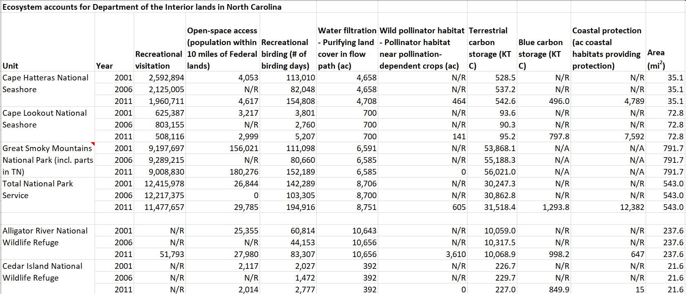

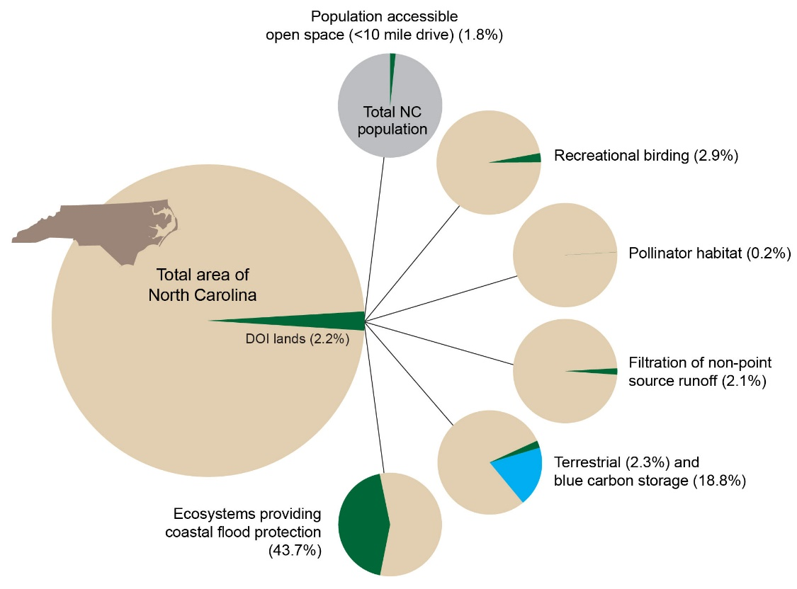

**Natural Capital Accounting Methods: Pilot ecosystem accounts for Federal and Tribal land in North Carolina**

A federal lands of the United States shapefile (USGS 2014) was used to define the boundary for each unit of Federal and Native American land in North Carolina. There were a total of 32 zones split into 5 management types: **National Park Service** – *Cape Hatteras National Seashore*, *Cape Lookout National Seashore*, and the *Great Smoky Mountains National Park* (including areas in Tennessee); **Fish and Wildlife Service** – *Alligator River National Wildlife Refuge (NWR), Cedar Island NWR, Currituck NWR, Great Dismal Swamp NWR (only the area in North Carolina), Mackay Island NWR, Mattamuskeet NWR, Pea Island NWR, Pee Dee NWR, Pocosin Lakes NWR, Roanoke River NWR, and Swanquarter NWR*; **National Forest Service** – *Croatan National Forest (NF), Nantahala NF, Pisgah NF, and the Uwharrie NF*. **Department of Defense** – *Air Force (Dare County Bombing Range, Seymour Johnson Air Force Base, Pope Air Force Base), Army (Military Ocean Terminal Sunny Point, Fort Bragg, Camp Mackall), Coast Guard (Coast Guard Station Elizabeth City), Marine Corps (Camp Lejeune, Point of March Target Airfield, Bogue Field Marine Corps Auxiliary Field, Atlantic Field Marine Corps Outlying Field, Marine Corps Air Station Cherry Point), Navy Harvey Point Defense Testing Activity*; **Native American reservations** – *Eastern Cherokee Reservation.*

The shapefile described above was used as an input to summarize the ecosystem services listed below.

*N/A is used when data are not applicable (e.g., coastal protection or blue carbon for non-coastal units, or visitation to a military base or Native American lands).

**N/R is used when data may exist, but were not available for a given year.

**Recreational visitation:**

Visitation data were acquired for National Park Service units, NWRs, and NFs. NPS estimates are provided annually through <https://irma.nps.gov/STATS/>. Wildlife Refuge visitation data are available only for select years and units via the Banking for Nature publications: <https://www.fws.gov/economics/divisionpublications/bankingonnatureimpacts.asp>. National Forest visitation estimates were obtained from the Forest Services’ National Visitor Use and Monitoring Program (NVUM). These also are only available for a subset of national forests for select years (2008 and 2013) from: <https://apps.fs.usda.gov/nvum/results/>.

**Population within 10 miles of Federal lands:**

As an indicator of populations who can readily access public lands (i.e., multiple times per month or more often), we buffered all Federal lands by 10 miles (boundaries of 10-mile buffers for individual management units may overlap). We then downloaded dasymetrically mapped county population data from SocScape (<http://www.socscape.edu.pl/index.php?id=high-resolution-grids>) for the years 2000 and 2010, which are based on Census data. County data were combined using Mosaic to New Raster in ArcGIS at 30 meter resolution. We then used ArcGIS’ Zonal Statistics tool to sum the total pixel value within a 10-mile buffer of each Federal management unit.

**Recreational birding days:**

Recreational birding days were obtained from an eBird point shapefile developed for the southeastern U.S. by Warnell et al. (2020). We rasterized the point shapefiles for 2001, 2006 and 2011 at 30 meter resolution and ran the Zonal Statistics tool in ArcGIS to sum the total number of birding days that fell within each Federal and Tribal management unit. Since 2001, eBird point records have grown in number with each point containing fewer observations (i.e., the data have become more fine-grained over time). To account for this, we scaled recreational birding data as a percentage of the state total for each land management unit for 2011, the most granular year, to the years 2001 and 2006. We expect more recent eBird data to further improve in the size and quality of its dataset with the 2012 release of an eBird mobile application.

**Water filtration (purifying land cover in flowpath):**

We used the ‘purifying land cover in flowpath’ 30-meter raster data to summarize the total acreage of land cover that provides water filtration within each Federal and Tribal management unit. The dataset was binary, indicating the presence/absence (0 or 1) of “natural” land cover types (e.g., forest, grassland, shrubland, wetland) located downstream from a nonpoint pollution source (developed land or cropland) and upstream of a water body (Warnell et al. 2020). We selected all pixels that had a value of 1 and converted the 30-meter pixel to acres.

**Wild pollinator habitat (habitat near pollination-dependent crops):**

We used the ‘wild pollinator habitat near pollinator dependent crops’ 30-meter raster dataset (Warnell et al. 2020) to summarize the total acreage of land cover providing potential pollinator habitat within a 1.1 km distance of pollinator dependent drops for each Federal and Tribal management unit. The dataset was a binary, presence/absence (0 or 1) raster; we selected all pixels that had a value of 1 and converted the 30-meter pixels to acres.

**Terrestrial carbon storage:**

Terrestrial carbon storage data were compiled by Sleeter et al. (2018), who estimated carbon stocks for land cover types in different ecoregions of the U.S. The National Land Cover Database (NLCD) for the years 2001, 2006, and 2011 provided land cover inputs. We used the U.S. Environmental Protection Agency’s Level III ecoregions (U.S. EPA) to delineate four North Carolina ecoregions (Piedmont, Blue Ridge, Middle Atlantic Coastal Plain, Southeastern Plains) used in Sleeter et al.’s (2018) estimates for carbon storage by land cover class. Sleeter’s classification also differentiates between protected and unprotected units in the Protected Areas Database of the U.S., but considered all Federal lands as “protected.” Sleeter’s classification does not consider wetland soil carbon storage, which can be substantial; we thus used estimates by Nahlik and Fennesay (2016) that provided values for wetland carbon storage for woody wetlands and emergent herbaceous wetlands in the Coastal Plains (Middle Atlantic Coastal plain and Southeastern Plains) and the Eastern Mountains (Piedmont and Blue Ridge). To avoid double counting wetland soil carbon storage with the blue carbon storage estimates, we only included woody wetlands in the Coastal Plains ecoregions, while including both woody wetlands and emergent herbaceous wetlands in the Eastern Mountains region. We converted all data to kilotons of carbon storage.

**Blue carbon storage:**

The blue carbon storage data is a 30-meter resolution raster available through Duke’s Digital Repository Research Data (Warnell and Olander 2020), with the original units in millions of tons of carbon dioxide, derived using the Integrated Valuation of Ecosystem Services Tradeoffs (InVEST) blue carbon model (Sharp et al. 2020). The habitat types used in the blue carbon assessment were seagrass (low and high salinity), and salt marshes (low and high salinity). We summarized these data using Zonal Statistics and then converted values to total kilotons of carbon storage.

**Coastal protection:**

The coastal protection shapefile (Warnell and Olander 2020) consisted of points representing 250-meter segments of coastline, modeled using the InVEST coastal protection model (Sharp et al. 2020). The shapefile contained multiple fields that provide values for a coastal exposure index (CEI) quantified using ranked inputs related habitat, wind, relief, geomorphology, waves and sea level rise. The two fields of importance for this analysis are the baseline coastal exposure index (UpdCEI) and the costal exposure index without habitats present (UpdCEInoH), which we used to select the points where there was at least a 20% increase in CEI without habitats present (i.e., where coastal ecosystems are providing a meaningful reduction in coastal vulnerability). We then ran the point to raster tool in ArcGIS to convert the shapefile to a raster dataset at 250m resolution. To account for alignment issues with Federal management unit boundaries (particularly in coastal environments where shorelines can change rapidly) we buffered all by 500 meters before running the Zonal statistics tool and summing the cell counts for each Federal management unit. Finally, we converted the number of 250 meter pixels to acres.

**References**

Nahlik, A., & Fennessy, M. (2016). Carbon storage in US wetlands. Nat. Commun. 7:13835. <https://doi.org/10.1038/ncomms13835>

Sharp, R., Douglass, J., Wolny, S., Arkema, K., Bernhardt, J., Bierbower, W., Chaumont, N., Denu, D., Fisher, D., Glowinski, K., Griffin, R., Guannel, G., Guerry, A., Johnson, J., Hamel, P., Kennedy, C., Kim, C.K., Lacayo, M., Lonsdorf, E., Mandle, L., Rogers, L., Silver, J., Toft, J., Verutes, G., Vogl, A. L., Wood, S, and Wyatt, K. (2020) InVEST 3.9.0.post39+ug.gdf3bc1b User’s Guide. The Natural Capital Project, Stanford University, University of Minnesota, The Nature Conservancy, and World Wildlife Fund. <https://storage.googleapis.com/releases.naturalcapitalproject.org/invest-userguide/latest/index.html>

Sleeter B.M., Liu, J., Daniel, C., Rayfield, B., Sherba, J., Hawbaker, T.J., Zhu, Z., Selmants, P.C., and Loveland, T.R. (2018). Effects of contemporary land-use and land-cover change on the carbon balance of terrestrial ecosystems in the United States. *Environ. Res. Lett.* 13:045006. <https://doi.org/10.1088/1748-9326/aab540>

U.S. Environmental Protection Agency. Level III and IV Ecoregions of the Continental United States. Accessed February 24, 2021. <https://www.epa.gov/eco-research/level-iii-and-iv-ecoregions-continental-united-states>

U.S. Geological Survey (2014). USGS 1:1,000,000-Scale Federal Lands of the United States 201412 Shapefile: National Atlas of the United States. <https://www.sciencebase.gov/catalog/item/5d150464e4b0941bde5b7654>

Warnell, K., & Olander, L. (2020). Data from: Coastal protection and blue carbon mapping for six mid-Atlantic states. Duke Research Data Repository. <https://doi.org/10.7924/r4pg1qw8p>

Warnell, K.J.D., Russell, M., Rhodes, C., Bagstad, K.J., Olander, L.P., Nowak, D.J., Poudel, R., Glynn, P.D., Hass, J.L., Hirabayashi, S., Ingram, J.C., Matuszak, J., Oleson, K.L.L., Posner, S.M., & Villa, F. (2020). Testing ecosystem accounting in the United States: A case study for the Southeast. Ecosystem Services 43:101099.